Winter Evangelism Emphasis (part two)
Berean Life Group (Acts 17:10-11)
December 4, 2022
Gordon Bolin/John Clark, Teachers | Room 611

Discussion Questions for Week 2:
- Discuss the various ‘emotional entry points’ that Sam described: reason, fear, shame, guilt. How would these entry points come up through natural conversations or questions? How does the gospel address these various entry points?

- Why are people more likely today to approach the gospel like the Pharisees rather than the tax collectors? (Luke 18:9-14) How should this change our approach to evangelism?

- Discuss the opportunities that exist if people will approach the church for ‘belonging.’ How can we prepare for these opportunities?

- What challenges could arise if people seek a sense of belonging before changing their behaviors or beliefs?

THE THREE CIRCLES:
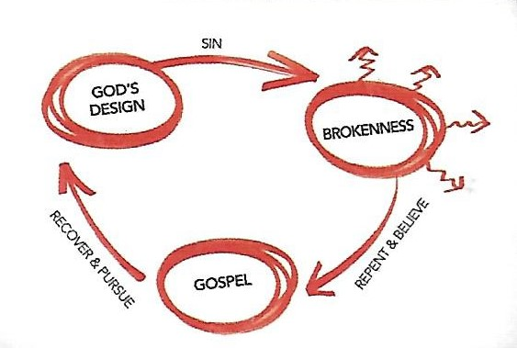

- Three Circles Video: https://youtu.be/lcj5G_4dwrI
- Dr. Sam Chan’s website: plus.citybibleforum.org/sharejesus]

OUR BEREAN CLASS SCHEDULE:
December 11-- No Life Groups (Providence Christmas Concerts)
December 18 – Class shares favorite Christmas memories
December 25 – Christmas Day (No Life Groups)
January 1 – New Year’s Day (No Life Groups)
January 8 – Begin the Book of Philippians

